Software Requirements Specification

“DEAN Acad & Dr ACAD”

Under the Guidance of

Prof. Atul Gupta

Mentor:

Nandita Gupta

TEAM MEMBERS:

Prakash Nidhi Verma | 2016185
Deepansh Jain | 2016074
Samyak Jain | 2016224

ERP$ source env/bin/activate
Fusion$ pip3 install -r requirements.txt
FusionIIIT$ python3 manage.py runserver
- Introduction

1.1 Purpose

The software requirement specification document is specifically designed to delineate the boundaries of the Dean Academics design and functionality. Parties interested in this documentation would include, but not be limited to the system owners, the system users, the project manager and the design team.

This is a software designed to manage different activities related to Dean Academics department of PDPM IIITDM Jabalpur. The software is designed to provide automated features to Faculty and Staff. The different activities that come under Dean Acad and Dr Acad department such as Scholarships, Assistantship, Thesis Submission etc.

1.2 Scope of the Document

This document will identify the pertinent software products we will develop including a SQLite and Python supported framework and web-based user interface for Dean Academics. The SRS will show that we will be utilizing SQL server and ASP for interfacing with the Input/Outputs. Finally, utilizing the security attributes we hope to address the valid security concerns about the networking and transmission of confidential health care information.

In addition to the specific design components of this software, this document will make clear the design team’s goals of creating value-added software which not only correctly captures faculties data, but then efficiently stores it, sorts it, retrieves it, and delivers this critical care information where it is needed by Dean Academics.

This software is deliberately focused on Faculty data and Dean Academics responsibilities. It is important to point out that this system will have functionality regarding appointment management, billing.

1.3 Intended Audience and Reading Suggestions

The audience for the document reading are users of the system such as administration body, Present Dean Academics and Dr Acad. Developers of the software will use it as a basis for making design and coding.

- Problem Description

2.1 Product Perspective

At present there is no such integrated automated system for Dean Academics in our college. All different activities are done manually and carried out independently. Current software will interact to provide necessary functionality in some activities.

Results(Grades) of students and scholarships details are the keystone to the Dean Academics; however, these records are not utilized to their fullest potential. Often records are inaccurate, misplaced,
and /or duplicated unnecessarily. In a world which recognizes the improvement of data digitization and networking as a constructive force which often increases efficiency while lowering costs; it is our view that faculty data and projects records networking could only benefit the quality of work and data offered.

2.2 Product Functions

The major functions that product will perform are:

2.2.1 Scholarships Details

Students will apply for scholarships then it will forward to then it will forward to Dr Acad then details will go for audit then forwarded to Dean Acad for Approval. If Dean Acad will Approve then it will forward to Account Section (Assistant Registrar) otherwise it will forward to.

2.2.2 Thesis Submission

Thesis will submit by Ph.D. Students then it will forward to Dean Acad. If Dean Acad will approve then it will forward to library.

2.2.3 Teaching Courses for semesters

Department head will float the courses then it will come for approval to Dean Acad. Dean Acad has to approve or disapprove with some comments.

2.2.4 Assistantship

Ph.D. Students will apply for assistantship then it will forward to department head then it will forward to Dean Acad for approval. If approved by Dean Acad then forward to account section for payment otherwise forward back to department head.

2.2.5 Applications like NOC, Admission Cancellation, Refund etc.)

Students or Faculty apply for proposals (NOC etc) then it will forward to respective head then head will forward to Dean Acad for approval or disapproval and recommended with comments. If Approval then forwarded to Director or Chairperson.

2.2.6 Results

Grades submit by Faculty with supporting documents then it will forward to head for moderation then after moderation it will forward to Dean Acad. Dean Acad verify it and send to APC community to attach proof of verification with it then Dean Acad will forward it to Dr Acad. Dr Acad will upload the final result sheet (Grades Only) along with supporting documents and forward to Dean Acad then Dean Acad will forward to chair person.

- Overall Description

3.1 Operating Environment

The software will be web-oriented and will run on all web browsers.

3.2 Design and Implementation Constraints

The document contains many use cases so when forming a design for the software we need to consider appropriate design models that will help the developers, coders and testers to implement their tasks. Legacy systems in place must be considered and modified to interface with the new system design.

Both the Dean Acad and Dr Acad database will need large storage capabilities and a process to archive outdated data.

The Internet connection is also a constraint for the application. Since the application fetches data from the database over the Internet, it is crucial that there is an Internet connection for the application to function.

3.3 User Documentation

A use case diagram is provided with the functional requirements to represent the entire information in a single picture. Further user documentations will be provided later.

3.4 Assumptions and Dependencies

All application and documentation will manage based on the priority hierarchy of Dean Acad and director.

- User (Actor) Characteristics

There are seven types of users that interact with the system.

They are:

- Student

- Head of Department

- Dean Academics

- Dr Acad

- Chairperson

- Director

- Faculty

Each of these seven types of users has different use of the system so each of them has their own requirements.

1.​Faculty​: A person who has been applying for different type of permission.

- Online Apply for Project Registration

- Request for Extension of project

- Reallocation of the fund Among Different Heads

- Request for closure of project

- Form for issuing of final UC, SE & Closure of Project

- Checklist for submission of project Proposal

2.​Dean RSPC​: A person who has approve different type of applications or forward to the director depends upon the rights.

3​. Director​: A person who is approved the different type of applications.

4.​Admin​: A person who is check and forward the different type of applications to the dean rspc staff.

- ​Deputy Registrar​: A person who is check and forward the different type of applications to the dean rspc staff.

- ​Head of Department​: A person who is check and forward the different type of applications to the dean rspc staff.

7.​Dean RSPC Staff​: A person who is check and forward the different type of applications to the dean rspc.

- Use Case Diagram

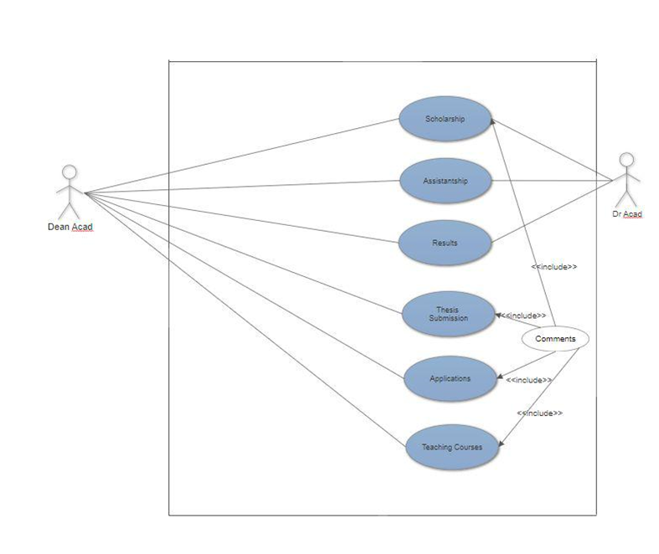
- Use Cases

1. Scholarships

Use Case Name | Scholarship
Version | 1.0

Description | Dean Academics and Dr. Acad approves the scholarship application.
Actors | Dean Academics and Dr. Acad
Pre-Condition | User is logged in and clicks on Scholarship button to view the
 | scholarship requests.
Main Flow | 1. Actor views the unapproved applications
 | 2. Verifies the applications
 | 3. Accept or decline the application with comment
Post-Condition 1 | Dr. Acad successfully approves the scholarship application and
 | transfers it to Dean Academics.
 | Dean Academics successfully approves the scholarship application
 | and transfers it to account section.
Post-Condition 2 | Dr. Acad declines the scholarship application.
 | Dean Academics declines the scholarship application and transfers it
 | to convener.
Issues | Any Network Error
2. Assistantship
Use Case Name | Assistantship
Version | 1.0
Description | Dean Academics accepts the PG Assistantship application sent by
 | the department head for payment.
Actors | Dean Academics
Pre-Condition | User is logged in and clicks on Assistantship button.
Main Flow | 1. Actor views the unapproved Assistantship applications
 | 2. Verifies the applications
 | 3. Accept or decline the application with comment
Post-Condition 1 | Dean Academics successfully approves the Assistantship application
 | and transfers it to account section.
Post-Condition 2 | Dean Academics declines the Assistantship application and transfers
 | it back to the head of department(HOD).
Issues | Any Network Error
3. Results
Use Case Name | Results
Version | 1.0
Description | Dean Academics and Dr. Academics view the grades of the students
 | before they are published.
Actors | Dean Academics and Dr. Academics
Pre-Condition | User is logged in and clicks on Result button.
Main Flow | 1. Actor views the unapproved Result applications
 | 2. Verifies the applications
 | 3. Accept or decline the application with comment
Post-Condition 1 | Dean Academics successfully approves the Results submitted by the
 | HOD and transfers it to Dr. Acad.
 | Dr. Acad successfully approves the Results submitted by the Dean
 | Academics and transfers it for final publishing.

Post-Condition 2 |  | Dean Academics declines the Result submitted by HOD and sends it
 |  | back to HOD for further evaluation.
 |  | Dr. Acad declines the result sent by Dean Academics and sends it
 |  | back to Dean Academics for further evaluation.
Issues |  | Any Network Error
4. Thesis Submission
Use Case Name |  | Thesis Submission
Version |  | 1.0
Description |  | Dean Academics approves the Thesis Submitted to him.
Actors |  | Dean Academics
Pre-Condition |  | User is logged in and clicks on Thesis Submission button.
Main Flow |  | 1. Actor views the unapproved Thesis
 |  | 2. Verifies them
 |  | 3. Accepts or declines them with comment
Post-Condition 1 |  | Dean Academics successfully approves the Thesis submitted and
 |  | sends it to library.
Post-Condition 2 |  | Dean Academics declines the submitted Thesis and sends it back to
 |  | HOD.
Issues |  | Network Error
5. Applications
Use Case Name |  | Applications
Version |  | 1.0
Description |  | Dean Academics approves or declines various application applied by
 |  | students including NOC, bonafide etc.
Actors |  | Dean Academics
Pre-Condition |  | User is logged in and clicks on Application tab to view the applied
 |  | applications.
Main Flow |  | 1. Actor views the applied Applications
 |  | 2. Verifies the applications
 |  | 3. Accept or decline the application with comment
Post-Condition |  | User is informed when his application is accepted or declined
Issues |  | Network Error
6. Teaching Courses
Use Case Name |  | Teaching Courses
Version |  | 1.0
Description |  | Dean Academics approves the list of faculty against the courses
 |  | they’d teach in a particular semester sent by HOD.
Actors |  | Dean Academics
Pre-Condition |  | User is logged in and clicks on Teaching Courses button
Main Flow |  | 1. Actor views the Teaching Courses tab
 |  | 2. Verifies the file sent by HOD
 |  | 3. Accept or declines with comment
Post-Condition |  | 1. Dean Academics accepts or declines the file
 |  | 2. HOD is informed

Issues | Network Error

- List of Open Issues (Unresolved Issues)

S. No | Issue Details | Category | How it can be resolved? | Any Other Relevant Information
1.
2.
3.
4.

- Suggestions and Feedbacks

